K-MODA
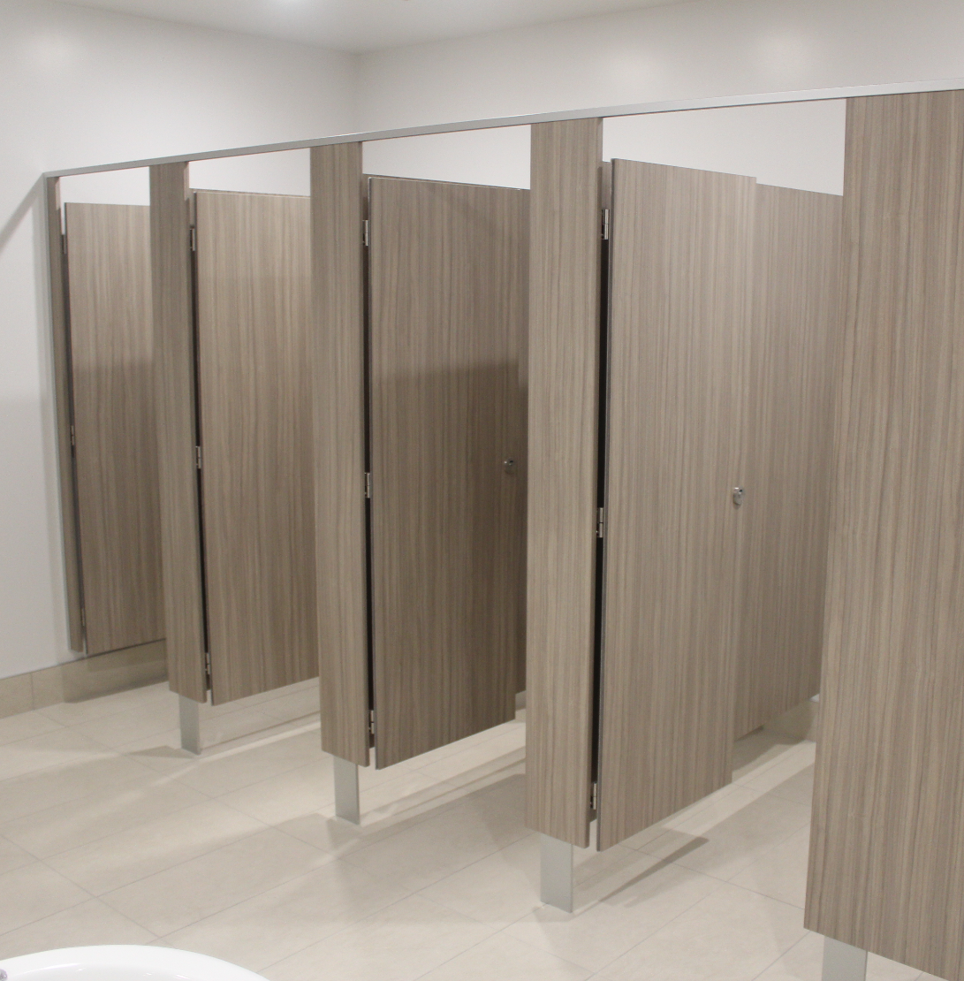
The K-Moda updates the classic style partition system with modern design features. K-Moda features stainless steel blade mounted pedestals and updated hardware. The K-Moda system is available in the widest range of materials meaning more colour selection and the ability to choose from 13mm, 18mm or 33mm width front panels. It achieves all of this with the same quality and affordability of previous system designs.
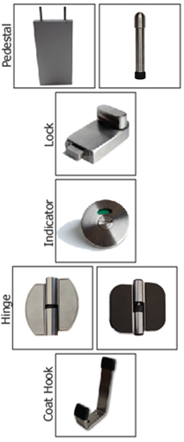

Laminate to choose from:
High Pressure Laminates Low Pressure Laminates Compact Laminates
KerMac Decorative Melteca KerMac Compact
Laminex Melamine Laminex Compact
Formica Structural Board

Applications Features
General Purpose Stainless Steel/Blade/Cast pedestal
Wet or dry areas (Compact Only Wet Areas) Anodised Aluminium channels
High Humidity (Compact only) Stainless Steel locks, coat hooks and fastenings

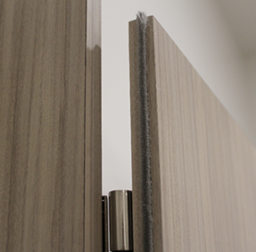
Standard Materials
18mm thick MDF laminated board
13mm Compact laminate
18mm Structural Board
Non-standard facing panels made to order
For high humidity areas Interior Plywood available
Anodised aluminium channel/headrail

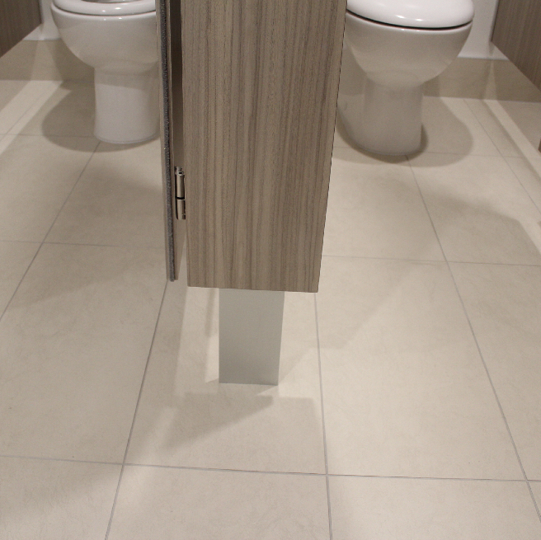
Optional Accessories:
Toilet roll holders
Grab Rails
Pull Handles
Shower seats and brackets
Paper towel dispenser
Waste receptacles
Powder coated aluminium trim

Dimensions and installation
Width and depth vary to suit application
Doors: Standard 600mm opening
Disabled 800mm minimum opening
Sliding doors on request
Standard height is 2000mm with 200mm floor clearance
KerMac include installation within the Auckland region. Alternatively, cubicles can be flat packed and shipped anywhere in Australasia with installation instructions included.

CAD drawings
Larger CAD Drawings available on www.kermac.co.nz in PDF, DWG and DXF formats
PH: (09) 273 1524 | ADDRESS: Unit I, 9 Lady Ruby Drive, East Tamaki, Auckland | PO Box 51
PH: (09) 273 1524 | ADDRESS: Unit I, 9 Lady Ruby Drive, East Tamaki, Auckland | PO Box 51 964

